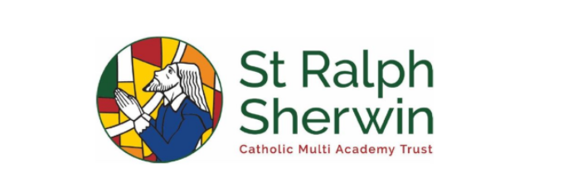

**Year 2 Pentecost 2 Newsletter**

Welcome back! I hope you all had lovely and restful week off and are ready for our final half term. It is all about great women from the past!

**Maths**

This half term, as mathematicians,   
we are going to be focusing on the following:

**Statistics**

We will look at block diagrams, tally charts and pictograms. The children will learn how to read information on these graphs and how to create their own.

**Position and Direction**This unit focuses on describing position in relation to other objects, describing lateral and rotational movement and describing and completing repeating patterns. Children will apply their previous learning about fractions to describe degrees of turn and their knowledge of 2D shapes. This unit also helps children to develop their logical and computational thinking in order to follow and describe sequences relating to movement, which prepares them for the following unit.  
 **REVISION  
For the final couple of weeks of Year 2, we will be recapping and applying our problem-solving skills to ensure all gaps are filled and cemented before the transition to Year 3.**Don’t forget to keep practising your times tables on Times Tables Rock Stars.

**English**  
This half term as writers, we will be focusing on:

**You must bring a hat** -   
This story is about a boy who is invited to a   
party but on the invitation, it states he MUST   
come with a hat and he can bring whomever he   
would like. He finds a monkey with a hat and as   
he is standing at the house of the party he is   
repeatedly told something else he needs to enter. We will use this book as a hook into our next book focuses.

**Vivienne Westwood** -   
Following on from You must bring a hat, we will   
be going back to the Little People, Big Dreams   
books. We will use Vivienne Westwood’s story to   
link closely with the history of the local area and   
textiles.

**Rosa Parks** -   
For our last book on Women who changed history,   
we will be focusing on Rosa Parks. We will look at   
her life, and what she did that made her so influential  
in modern history.

We are going to be publishing the following genres   
of text:   
**invitations, narratives and thank you letters.**

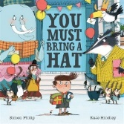

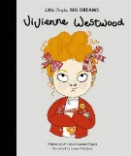

**RE**Our focus for RE this half term will be Rules and Treasures.   
  
We have two learning questions to answer this half term, **‘Why do we need rules?’** and **‘Is the world a treasure?’**.   
Both questions allow us to connect deeper with our Catholic Faith and encourage us   
to think deeper about how we can make connections to Jesus’ life.

**Which women changed history?**

For our topic learning this half term, we are going to become historians and take a trip through modern history.

We are going to be working within the National Curriculum objectives of ‘events beyond living memory that are significant nationally or globally’, ‘the lives of significant individuals in the past who have contributed to national and international achievements’, and ‘significant historical events, people and places in their own locality’.

**In week one, as historians,** we will be solving the question ‘Who is Vivienne Westwood and what did she do?

**In week two, as historians**, we will look at ‘What did Florence Nightingale and Mary Seacole do to change nursing?’

**In week three, as historians**, we will research who Amelia Earhart was and what she did in the past?

**In week four, as historians**, we will explore ‘Why did Rosa Parks do what she did?’

**In week five, as historians,** we will answer the question ‘Have I ready any books by Beatrix Potter?’

**In week six, as historians**, we will research ‘Who was Frida Kahlo?’

**Guided Reading**

For our Guided Reading this half term, we are going to be developing our fluency and expression when reading aloud. As we become readers, we will answer questions based around retrieval and inference. We use the DERIC approach to Guided Reading (Decode, Explain, Retrieval, Interpret and Choice).

We will be developing our skills in answering reading questions and then moving on to reading the book The Tale of Peter Rabbit.

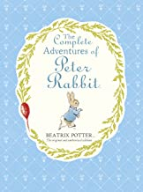

**Science**

Our Enquiry Question for this half term is **‘What actually is a plant?’**

This topic of our science learning is all about plants and how plants can grow healthily. We will be carrying out a comparative test where we are restricting water and sunlight from seeds to see the effects of this! We will also be looking at the life cycle of a plant! We will also be growing broad beans and sunflowers – who’s sunflower will grow the tallest?!

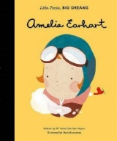

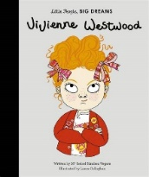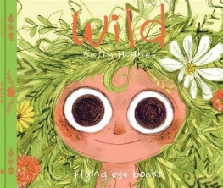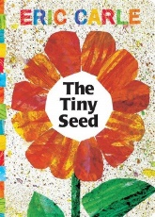

**How can you help?**

As we enter the last half term together of Year 2, I just want to say thank you for all your support this year! The children have been such a pleasure to teach, and I have felt really welcomed to St Charles by all of you. It has been lovely to see the children growing and achieving.

We have our SATs tests at the end of June so any practise at home would be beneficial, materials are continuing to be sent out for homework.

If you have any questions, please don’t hesitate to get in touch via the office or on the gate.

Mrs Greenwood-Knapper and Miss Walker.