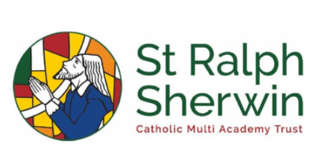
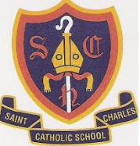
Year 4 Pentecost 2 Newsletter
Welcome back, I hope half term was filled with lots of lovely family time!
Below is all the learning we will be doing this half term.
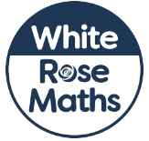

English
This half term as writers, we will be focusing on:
Raid of Lindisfarne -
Lindisfarne raid, Viking assault in 793 on the island of Lindisfarne (Holy Island) off the coast of what is now Northumberland. The monastery at Lindisfarne was the preeminent centre of Christianity in the kingdom of Northumbria. The event sent tremors throughout English Christendom and marked the beginning of the Viking Age in Europe. Using this Historical information, we will create newspaper reports in role during this raid!
How to train your Dragon -
How to Train Your Dragon is a series of children's
books written by British author Cressida Cowell.
The books are set in a fictional Viking world and
focus on the experiences of protagonist Hiccup
Horrendous Haddock the Third, as he overcomes
obstacles on his journey of "becoming a hero, the
hard way". Using this, we will create descriptions of characters and instructions on how to train your dragon!
An incomplete guide to Dragons -
Long ago, the world was full of dragons. But what
happened to them? Where are they now? These
pages are taken from the notebooks of Viking Hero
Hiccup Horrendous Haddock the Third when he
was just a boy. A keen dragon watcher, Hiccup
paints a picture of the brilliance and fire and spirit
of that lost dragon world. Featuring dragon profiles,
dragon anatomy, dragon riding tips and lots more must know info e.g. how to spot the difference between an arsenic adderwing and a glow worm (you don't want to mix those two up) and what to do when confronted with a Hellsteether.

Maths
This half term, as mathematicians,
we are going to be focusing on the following:
Time
This unit builds on the concepts of time learned in Year 3, particularly when telling time to the minute. Children will link their prior knowledge of facts to bar models that will help them convert between units. Before they start this unit, it is expected that children:
• can read and write times to the nearest minute
• know the number of seconds in a minute, minutes in an hour and hours in a day
• understand how to express 12-hour times digitally, including using the terms am and pm.
Statistics
In this unit, children build on the work from Year 3 on statistics, where they were introduced to basic pictograms, bar charts and tables. Children are encouraged to explore the range of information which they can get from the data that is presented to them. Children will explore how the structure of line graphs, and data presented within them, differs from bar charts. Children should then be able to apply this knowledge through the remaining units in Year 4.
Position and Direction
In this unit, children will learn to plot coordinates on a grid and describe positions using coordinates. They will be able to use this knowledge to draw 2D shapes on a grid.

During the first few weeks of this term children will complete their Multiplication Times tables Check. This will be 25 questions up to the 12 times tables. Each question must be answered in 6 seconds. Please help your child to practice as much as possible.

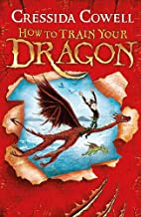

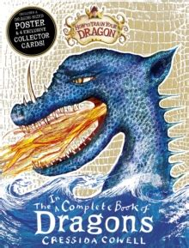

RE
Our next unit of learning is based around ‘Building Bridges’ Christians believe that, in Jesus Christ, the world has been reconciled
to God. Through and in Christ, every human being is offered the power to reach out in forgiveness and peace, to receive and to offer reconciliation. We will then look at ‘World’. Christians believe that the diversity of the world and its people is God’s gift. Jesus in his life and gospel, challenges people to appreciate diversity and to create with it a harmony that reflects the unity of Father, Son and Holy Spirit. This is reflected in the work of CAFOD.


The Vikings -
Helpful, nasty or both?
For our topic learning this half term, we are going to become historians and delve into the history of the Anglo Saxons and their impact on Britain.
Here is an outline of our learning for this half term:
In week one, as historians, we will be answering where did the Vikings come from?
In week two, as historians, we will uncover what legacy did the Vikings leave in Britain.
In week three, as historians, we will research where and when the Vikings first landed.
In week four, as historians, we will see if you can spell and write your name in Viking Runes.
In week five, as historians, we will answer whether or not the Vikings were early engineers.
In week six, as historians, we will investigate and examine why the Vikings had so many Gods.
All our history learning this half term links with the following National Curriculum areas:
Pupils should continue to develop a chronologically secure knowledge and understanding of British, local and world history, establishing clear narratives within and across the periods they study. They should note connections, contrasts and trends over time and develop the appropriate use of historical terms. They should regularly address and sometimes devise historically valid questions about change, cause, similarity and difference, and significance. They should construct informed responses that involve thoughtful selection and organisation of relevant historical information. They should understand how our knowledge of the past is constructed from a range of sources. 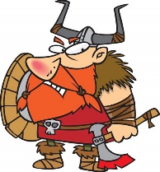
Guided Reading
For our Guided Reading this half term, we are going to be developing our inferential and retrieval skills. As we become more confident with this, we will work towards timed exercises and more independent question answering. We use the ERIC approach to Guided Reading (Explain, Retrieval, Interpret and Choice). To build these skills this half term, we are going to be finishing Kensuke’s Kingdom, before moving onto There’s a Viking in my bedroom.
After falling overboard from his longboat,
Sigurd the Viking finds himself in modern
-day Flotby - a small English seaside town.
Finding refuge in the aptly named Viking
Hotel, Siggy's attempts to embrace modern
ways end in disaster. His attempt at
romance is no better off as even the
course of true love doesn't run smoothly
when Siggy's involved!

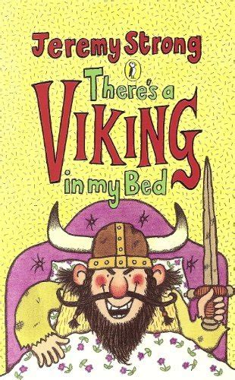

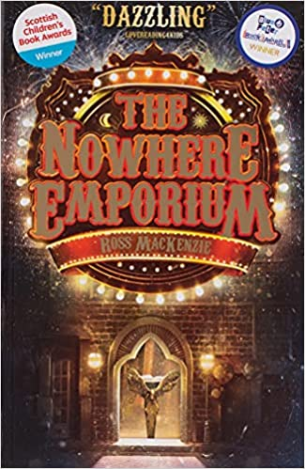
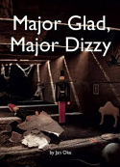
Science
We are going to be continuing with our Science learning based around ‘Living things and their habitats. We are going to be investigating the question:
Who's the best at hide and seek - vertebrates or invertebrates?

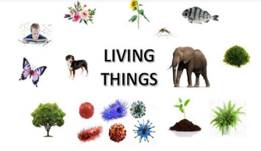

How can you help?
If you ever need to contact me, just catch on the gate on Tuesday mornings, or any time after school. I can also be contacted through the info@cha.srscmat.co.uk email address – Miss Smith will forward anything that is meant for me!
This half term, there will be the Multiplication Tables Check (MTC). This is a statutory test for Year 4 children in England. The purpose of the check is to determine whether your child can fluently recall their times tables up to 12, which is essential for future success in mathematics.
We have been carrying our TTRS Soundchecks last half term, and we are super confident with all the children – I am also incredibly proud of how much their scores have improved.
Any questions, just ask.
Mrs Brassington and Miss McGrail

