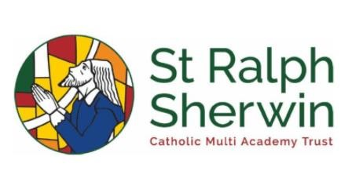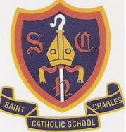

Year 6 Pentecost 2
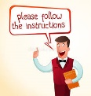
Welcome back, I hope you enjoyed your break and have come back full of energy. This half term we will continue to prepare for High School and their upcoming transitions. We hope the children love their final half term at St Charles. They have many nice things to look forward to and we hope they will enjoy it.
Maths
Problem solving – the four operations, fractions, decimals, percentages, ration and proportion, time, position and direction and the properties of shape. During these different units the children with look at the different types of reasoning and problem, solving questions and try to get a better understanding of them.

Statistics - In this unit children learn what the mathematical mean is and how to calculate it and they consider when using the mean is particularly useful, for example when comparing sets of data of different sizes. Children learn what a pie chart is and how to interpret one, they compare tally charts and bar charts and learn when a pie chart is the best way to display data. Children develop their ability to interpret and create line graphs.

Project – During this part of the term, the children will be put into small groups, and they will come up with a project. They will have to work together as a group to come up with the idea, work out the costs to get it up and running, how much they would sell it for and how much profit they would make.
English

Instructions:

The children will be writing a set of instructions for the year 5 class to follow. They will be instructing them on how to survive in year 6. They have been given a free range on this subject – they can either with a formal set or instructions or an informal set. Whichever set they decide to write, they will need to use all the correct features throughout.
Biography:

The children will be writing a biography on of their own choice, they will be researching different aspects of her life and then using their research, write a detailed account. They will look at the features, which include written formally, use of compound and complex sentences, containing connectives. It must be written in the past tense and in chronological order.

Letter of complaint
We will be writing a letter of complaint from the
witch about the shocking behaviour of Hansel
and Gretel. We will capture the structure of the
letter to show the emotions and demands of the witch. We will also use different causal conjunctions to explain in detail and use modal verbs to show intention.

Non -Chronological report.

Finally, the children will be writing their own non-chronological – linking to their topic, the children will be looking at the different jobs that woman had during World War 1. They will need to research them, understand why the women had to complete these jobs and why they were important during this time in British history. During this unit, we will be focusing on our structural devices, such as sub-headings, bullet points, diagrams and fact boxes. We will also be considering our formality and tone and technical and factual language. The children will decide if they want to complete a written piece or make a power point to show their understanding and findings.



RE
Dialogue and Encounter
As pupils reach the end of the primary phase of their education, they should consider what dialogue means in action. The Catholic Bishops’ Conference of England and Wales identified different ways Catholics can enter dialogue with people of goodwill in their document ‘Meeting God in friend and stranger’ (2010). The pathways most appropriate for pupils are:
• The dialogue of life – what it means to be a good neighbour.
• The dialogue of action – how Christians and others collaborate for justice and freedom for all people.
• The dialogue of religious experience – how people share their spiritual riches.

Guided Reading
We will finish reading ‘The Wizard of Oz’ by Frank L Baum. We will be reading this text as a class and answering different questions relating to this text. When a tornado rips through Kansas, Dorothy and her dog, Toto, are whisked away in their house to the magical land called Oz. They encounter different magical creatures on the way and follow the Yellow Brick Road towards the Emerald City to meet the Wizard. During the journey, they meet a Scarecrow, a Tin Man, a Cowardly Lion and The Wicked Witch of the West. “Close your eyes and tap your heels together three times. And think to yourself, there's no place like home.”
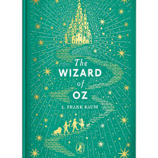
History - Who were the Suffragettes and what did they achieve?
In this unit, we will be looking at the Suffragettes and how they made a massive difference to women’s rights (not just in their time but also in the years that followed). The children will be looking at the different things they achieved, and the main women involved.

In week one, as historians, we will be finding out who the suffragettes were and how they had an impact on women and their rights in England.

In week two, as historians, we will look at events and then research what life was like for women during the First World War.

In week three, as historians, we will find out about women’s rights during this period and why was it illegal for them to vote. We will also find out when and why they were allowed to vote.

In week four, as historians, we will look at, in detail, Emmeline Pankhurst and how she was very important to this movement. The children will make a power point about this important lady.

In week 5, as historians, we will be looking how the Suffragettes changed women’s rights and how this has affected the lives of women to this present day.

Science
In Science this half-term we will be looking at ‘Living things and their Habitats’. We look at how experts classify different species and how Carl Linnaeus created a classification system that is used around the world today. During this unit of work, we will be looking at different Curious Creatures and micro-organisms and the children will classify them and then try to use the Linnaeus system.
In week one, we look at how to group animals. We will look at different ways to group and classify animals.
In week two, we will learn about Carl Linnaeus and how he sorted living things into groups.
In week three, we will focus on key characteristics of animals and identifying these.

In week four, we will investigate what micro-organisms and how these spread.

In week five, we will learn about the different types of micro-organisms.

In week six, we will look at how we can classify the living things around our school. 
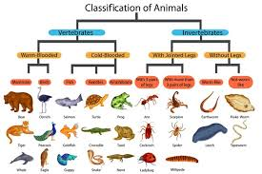

How can you help?
Weekly Homework - Homework will be set on a Friday and will need to be completed by the following Friday. If you have any trouble accessing homework online or would prefer a paper copy, please come and see me and I can arrange this for you.
- Spelling Shed – please ensure your child is accessing this regularly at home, there are certificates and rewards for children who access this! If your child has misplaced their login, please let me know.
- TT Rockstars – please ensure your child is accessing this regularly at home too, it is extremely important that they regularly practice and apply their multiplication and division knowledge.
- Remember to read every night with your child and sign their diary too!

Thank you for your continued support and if you have any questions about your child’s learning or progress, please don’t hesitate to contact me.

Mr Robinshaw, Ms McGrail and Mrs Healy.

